CALL FOR APPLICATION
The University of Pécs, Faculty of ZENE and Visual Arts calls for applications for participating in the Pannónia Scholarship Program Student Mobility for Learning Programme for the autumn semester of the 2024/2025 academic year

The object of the call for applications:
Long-term student mobilities for study purposes are student mobilities based on inter-institutional agreements, implemented with the purpose of obtaining credits, and directed to specific target countries, the duration of which is a minimum of 2 months and a maximum of 5 months.
Student mobilities for academic purposes can be implemented in any study area and cycle, including doctoral training. The study period abroad must be part of the student's study program aimed at obtaining a diploma within any study cycle, and the sending institutions must accept it and fully comply with the curriculum structure in terms of the time of student mobility in a proportional manner. The credit acquisition and recognition process must be recorded in the mobility agreement of the student participating in the mobility.

Within the Pannónia Scholarship Programme, students studying abroad also enroll at home, establish active student status, pay any tuition fees at their home institution, and receive their regular scholarship for the duration of their stay abroad.

Duration of study mobility abroad: minimum 2 months - maximum 5 months
Period of study mobility: August 25, 2024 - February 10, 2025
Currency of the scholarship: HUF

Pannónia Scholarship Program students studying abroad:
- spend 2-5 months abroad (depending on the year they are in and the partner institution);
- do not pay tuition fee at the receiving institution; however may be obliged to pay registration/administration fee (mainly at German universities);
- enrol at the home university, establish an active student status, pay any applicable tuition fees to their home university, and receive their grants for the period of studying abroad;
- do not obtain their degree before ending the mobility;
- 100% credit recognition (credits earned abroad are 100% accepted by PTE)
- The program/PTE/Sending Faculty guarantees recognition of the credits earned abroad for the students: the activity carried out during the student's study mobility must be accepted by the sending institution and must fully comply with the curriculum structure, thus avoiding possible slippage, which is one of the biggest deterrent among students.
- The conclusion of the Support Agreement is only possible if there is a Learning Agreement signed by all three parties. Completion and compliance with the courses agreed in the Learning Agreement is binding for both the student and the institutions.
- Diverse mobility options available across the globe!
Thanks to the extensive mobility options of the Pannónia Scholarship Program, everyone can find what best suits their professional career path.

Destination countries:
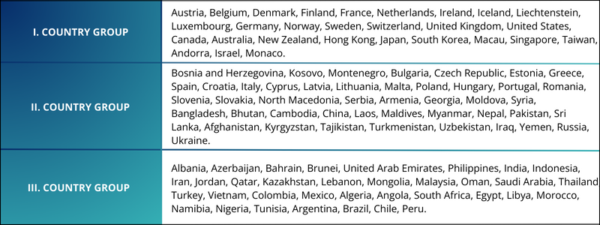
Who can apply?
General participation conditions:
- the student is pursuing studies aimed at obtaining a diploma (Bachelor, Master, Undivided, PhD) at the institution;
- the student is NOT a Stipendium Hungaricum or Diaspora scholarship holder
- the student has 1 completed active semester at the time of application;
- in the semester in which the mobility takes place, the student has an active student status at PTE; and do not obtain their degree before the end of the mobility period;
- the student has a high communication level of English and/or language competences corresponding to the native language of the destination country (minimum B2 but recommended C1);
- students with Stipendium Hungaricum scholarship cannot apply for Pannónia grant
- the student is allowed to participate in a study mobility period for a maximum of 12 months per academic cycle, regardless of the number or type of mobility activities
- meet the application requirements announced by the given faculty.

Documents to be submitted by the applicants:
• Motivation Letter (approximately 1500 characters)
• Professional CV
• Language certificate(s)
•Transcript of records (2 previous semesters)
• Certificate of professional or public activities (optional)

Grants for the academic year 2024/2025:
The amount of the grant depends on the length of the study period (number of days) and on the host country.
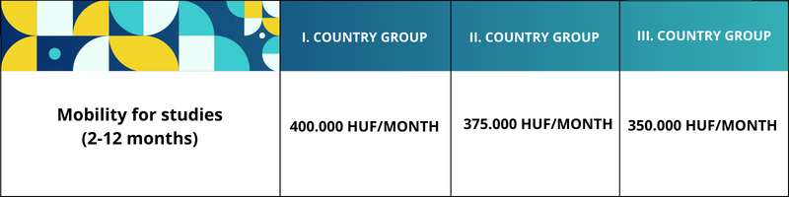
Students with fewer opportunities are entitled to an additional support of HUF 100,000 per month, in addition to their individual support provided within the framework of the Pannónia Scholarship Program.
The equal opportunity support is provided on the basis of a separate application.
The announcement and evaluation of the application and the conclusion of contracts are institutional competences.

Deadline and method of submitting the application:
Application deadline: March 14, 2024, at 1:00 p.m. on the mobility online interface. Further information about the application will be provided by the faculty coordinator:
Beáta Seres
seres.beata@pte.hu
PTE MK, E/33 room 102
Apply through the link given on this website “Apply here”:
https://international.pte.hu/mobility-studies-pannonia-scholarship-programme
Please note that incomplete applications, applications that do not meet the conditions, or applications arriving after the deadline will not be accepted!
During the preparation of the application, check the course offerings on the websites of the partner universities, the equivalence table appearing on the faculty website; find out in which language and at which training level (bachelor or master's degree) courses are advertised.

AVAILABLE PARTNER UNIVERSITIES

UNIVERSITY | SUBJECT AREA | SZINT | Személy/hónap teljes tanévre vonatkozóan | Oktatás nyelve
Brno University of Technology  Czech Republic | VISUAL ARTS | BA, MA, DLA | 1x5 | cseh, angol
University of Hertfordshire  UK | VISUAL ARTS / MUSIC | BA | 2/3x5 | angol
Staatliche Akademie der Bildenden Künste Karlsruhe  Germany | VISUAL ARTS | BA, MA, DLA | 1x3 | angol, német
Academy of Arts in Banska Bystrica, SLOVAKIA | VISUAL ARTS/  MUSICművészet | BA,MA,DLA | 2/2x5 | szlovák, angol
Academy of Arts Novi Sad, Serbia | VISUAL ARTS/  MUSIC | BA, MA | 2x5 | szerb, angol
Josip Juraj Strossmayer  University of Osijek  CROATIA | MUSIC/  PERFORMING ARTS/VISUAL ARTS | BA, MA | 3/2x5 | horvát, angol
Instituto Politécnico do Porto (IPP)  Portual | MUSIC | BA, MA | 2x5 | angol
Conservatorio Superior de ZENEa “Eduardo Martinez Torner” del Principado de Asturias  Oviedo, Spain | MUSIC | BA | 3x5/2x9.5 | spanyol

