CALL FOR APPLICATIONS
The University of Pécs calls for applications for participating in the Pannónia Scholarship Program Student Mobility for Traineeship for the fall semester of the 2026/2027 academic year

The object of the call for applications:
The purpose of the call is to offer traineeships at companies or organizations in another program country, lasting a minimum of 2 and a maximum of 4 months. The aim is to assist in acquiring the skills necessary in the community labour market and to understand the economic and social culture of the host country. The host enterprise can be active in the labour market or in the fields of education, training, or youth, with the exception of National Offices and EU bodies.

Within the framework of the Pannónia Scholarship Program, successful applicants have the opportunity to complete traineeships at universities, professional organizations, and non-profit organizations in the program country. The aim of the mobility can be a traineeship combined with specialized studies. Mobility can only take place if the credits obtained during the foreign traineeship are accepted by the sending institution and are credited to the student’s progress at home (with the PTE credit system) and /or a Diploma Supplement is issued.
Students participating in the Pannónia Scholarship Program abroad also enrol at home, establish an active student status, pay any tuition fees at home, and receive their regular scholarship during their stay abroad.
The credit acquisition and recognition process must be recorded in the mobility agreement of the student participating in the mobility.

Duration of study mobility abroad: minimum 2 months (62 days) - maximum 4 months (120 days)
Period of study mobility: 1 July 2026-
Currency of the scholarship: HUF
Scholarship disbursement: 90% pre-financing – 10% post-financing
Working hours: minimum 30 working hours/week.

Pannónia Scholarship Program students studying abroad:
- spend 2-4 months abroad (min. 62 days)
- enrol at the home university, establish an active student status, pay any applicable tuition fees to their home university, and receive their grants for the period of studying abroad.
- do not obtain their degree and maintain an active student status before ending the mobility.
- 100% credit recognition (credits earned abroad are 100% accepted by PTE)The conclusion of the Support Agreement is only possible if there is a Mobility Agreement signed by all three parties. Completion and compliance with the activities agreed in the MobilityAgreement is binding for both the student and the institutions.

We would like to draw your attention to the fact that mobility cannot be started without a signed and faculty-approved Mobility Agreement, the decision of the Faculty International Committee, and the signed grant agreement. The university will not transfer funds after the start date of the mobility if the above-mentioned conditions are not met.

Diverse mobility options available across the globe!
Thanks to the extensive mobility options of the Pannónia Scholarship Program, everyone can find what best suits their professional career path.

Destination countries:
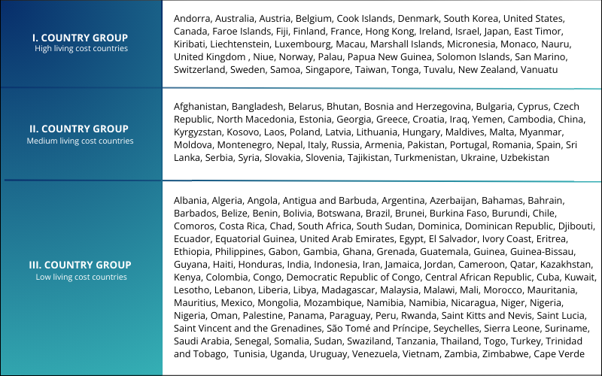
Who can apply?
General participation conditions:
- the student is pursuing studies aimed at obtaining a diploma (Bachelor, Master, Undivided, PhD) at the institution.
- the student has at least 1 completed active semester at the time of application.
- in the semester in which the mobility takes place, the student has an active student status at PTE; and do not obtain their degree before the end of the mobility period.
- the student has a high communication level of English and/or language competences corresponding to the native language of the destination country (minimum B2 but recommended C1).
- students with Stipendium Hungaricum scholarship cannot apply for this Pannónia grant.
- the student is allowed to participate in a study mobility period for a maximum of 12 months per academic cycle, regardless of the number or type of mobility activities.
- meet the application requirements announced by the given faculty.
In case you are in the semester of your graduation, you must complete your traineeship in the month before the completion of all coursework requirements and obtaining your pre-degree certificate (absolutorium).

Documents to be submitted by the applicants:
• Professional CV
• Motivational Letter (at least 1500 characters, including your name and major)
• Official Transcript of Records of the 2 previous semesters issued by the Registrar’s Office – 1 semester in case of a first-year student
• Language certificate(s)
• Recommendation Letter (from a senior lecturer, associate professor or full professor)
• Certificate of professional or public activities (optional)
• Acceptance letter from the host institution (including the exact dates)

Grants for the academic year 2026/2027:
The amount of the grant depends on the length of the study period (number of days) and on the host country.
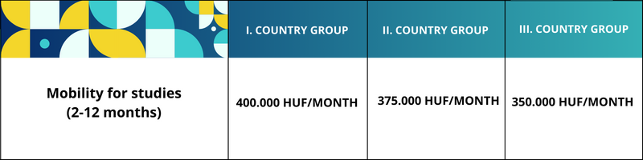

The final scholarships are calculated daily based on the submitted support agreement.
The amount of the scholarship does not necessarily cover all costs incurred during the stay abroad, these must be covered from other sources.

The amount of the scholarship does not necessarily cover all costs incurred during the stay abroad, these must be covered from other sources.
Under the general mobility program, students participating in partial mobility training are eligible for travel support if the destination of their mobility is more than 2,000 km away. In this case, based on RVÉ Decision 2025.11.13. Based on the table below, travel support may be granted based on an institutional decision.

Distance |  | Travel allowance available
Minimum limit | Maximum limit | Travel allowance available
2 000 km | 2 999 km | 86 900 Ft
3 000 km | 3 999 km | 139 200 Ft
4 000 km | 7 999 km | 308 880 Ft
8 000 km |  | 485 800 Ft

Travel distance is calculated exclusively via Erasmus+ Distance Calculator:
https://erasmus-plus.ec.europa.eu/resources-and-tools/distance-calculator
Application deadline at the faculty:

Deadline and method of submitting the application: 15.00 h (sharp) 12 th March 2026 in Neptun. You can find the application form in Neptun under the "Requests" tab.

Evaluation of submitted applications:

Please note that incomplete applications, applications that do not meet the requirements, or applications arriving after the deadline will not be accepted. Therefore, please only submit your application in Neptun if you have all the necessary documents at your disposal!
The submitted applications will be evaluated by the professional committee set up by the faculty, the Faculty External Affairs Committee.
EVALUATION CRITERIA FOR APPLICATIONS
The International Relations Committee evaluates and scores the applications based on the criteria listed in the table below.
Criterion | Maximum Score
1. Academic performance in the major subject / academic portfolio | 30
2. Result of the oral interview | 20
3. Presentation of professional and artistic activities and ambitions in the application | 20
4. Foreign language communication skills / language certificates | 20
5. Public activity, openness to networking, social skills | 10
Total | 100

1. Academic Performance in the Major Subject / Academic Portfolio
Only completed semesters prior to the submission of the application are taken into account, during which the applicant completed at least 15 credits and received a grade of at least 3 (satisfactory) in the major subject.
The score is calculated based on the simple arithmetic mean of the applicant’s grade averages.
Grade Point Average | Score
3.000–3.999 | 17 points
4.000–4.099 | 20 points
4.100–4.199 | 21 points
4.200–4.299 | 22 points
4.300–4.399 | 23 points
4.400–4.499 | 24 points
4.500–4.599 | 25 points
4.600–4.699 | 26 points
4.700–4.799 | 27 points
4.800–4.899 | 28 points
4.900–4.999 | 29 points
5.000 | 30 points

2. Result of the Oral Interview
A maximum of 20 points may be awarded based on the applicant’s performance during the oral interview.

3. Presentation of Professional and Artistic Activities and Ambitions in the Application
- Participation in the National Scientific Students’ Conference (OTDK): 4 points
- Placement among the top ten at the national final of the Scientific Students’ Conference, top three placement at the faculty round, or receiving a special prize: 4 points
- Participation in an academic competition: 2 points
Award-winning participation: 4 points
- Professional publication published in a professional or artistic journal: 6 points
- Membership or activity in a scientific students’ association or honors college: 3 points
- Verified participation in other professional events or conferences, giving a presentation, or submitting a written report or summary: 2 points per activity, maximum 4 points
- Hungarian Republic Scholarship: 5 points

4. Foreign Language Communication Skills / Language Certificates
- State-recognized intermediate-level “C-type” language certificate: 5 points
- State-recognized advanced-level “A-type” or “B-type” language certificate: 7 points
- State-recognized advanced-level “C-type” language certificate: 10 points
If the applicant holds a language certificate in the language of instruction of the host institution: +5 points
Additional language certificates:
- Additional intermediate-level “A-type” or “B-type” certificate: 1 point
- Additional intermediate-level “C-type” certificate: 3 points
- Additional advanced-level “A-type” or “B-type” certificate: 3 points
- Additional advanced-level “C-type” certificate: 5 points
If the applicant does not possess a language certificate, a language interview will determine the score.

5. Public Activity, Openness to Networking, Social Skills
- Executive board membership in the Student Union: 6 points
- Active participation in the work of the Student Union: 4 points
- Committee membership: 4 points
- Active tutor/mentor activity: 4 points
- Membership in an international organization: 8 points
- Other public or community activities – additional points may be awarded; please specify

For further information related to submitting the application, you can contact Beáta Seres, the faculty coordinator at beata.seres@pte.hu (E/33 building, room 102)

Prof. Péter Lengyel
Dean
Faculty of Music and Visual Arts
Pécs, 2026

