CALL FOR APPLICATION
The University of Pécs calls for applications for participating in the Pannónia Scholarship Program Student Mobility for Learning Programme for fall semester of the 2026/2027 academic year I. semester

The purpose of the call for applications:
Long-term student mobilities for study purposes are student mobilities based on inter-institutional agreements, implemented with the purpose of obtaining credits, and directed to specific target countries, the duration of which is a minimum of 2 months and a maximum of 5 months.
Student mobilities for academic purposes can be implemented in any study area and cycle, including doctoral training. The study period abroad must be part of the student's study program aimed at obtaining a diploma within any study cycle, and the sending institutions must accept it and fully comply with the curriculum structure in terms of the time of student mobility in a proportional manner. The credit acquisition and recognition process must be recorded in the mobility agreement of the student participating in the mobility.
While studying abroad within the framework of the Pannónia Scholarship Programme, students study abroad remain enrolled at their home institution, keep an active student status, pay any applicable tuition fees at home, and continue to receive their regular scholarships during the mobility period.
Duration of study mobility abroad: minimum 2 months - maximum 5 months (62-150 days)
Period of study mobility: 24 August, 2026 – 5 February, 2027
Currency of the scholarship: HUF
Scholarship disbursement: 90% pre-financing – 10% post-financing

Pannónia Scholarship Program students studying abroad:
- spend 2-5 months abroad (depending on the year they are in and the partner institution);
- do not pay tuition fee at the receiving institution; however may be obliged to pay registration/administration fee (mainly at German universities);
- enrol at the home university, establish an active student status, pay any applicable tuition fees to their home university, and receive their grants for the period of studying abroad;
- do not obtain their degree before ending the mobility;
- 100% credit recognition (credits earned abroad are 100% accepted by PTE)
- The program/PTE/Sending Faculty guarantees recognition of the credits earned abroad for the students: the activity carried out during the student's study mobility must be accepted by the sending institution and must fully comply with the curriculum structure, thus avoiding possible slippage, which is one of the biggest deterrent among students.
- The conclusion of the Support Agreement is only possible if there is a Learning Agreement signed by all three parties. Completion and compliance with the courses agreed in the Learning Agreement is binding for both the student and the institutions.
- Diverse mobility options available across the globe!
Please note that mobility cannot commence without a signed and approved Learning Agreement, a decision by the Faculty Foreign Affairs Committee, and a signed grant agreement. The university will not make any transfers after the start date of mobility if the above conditions are not met.
Thanks to the extensive mobility options of the Pannónia Scholarship Program, everyone can find what best suits their professional career path.
Destination countries:
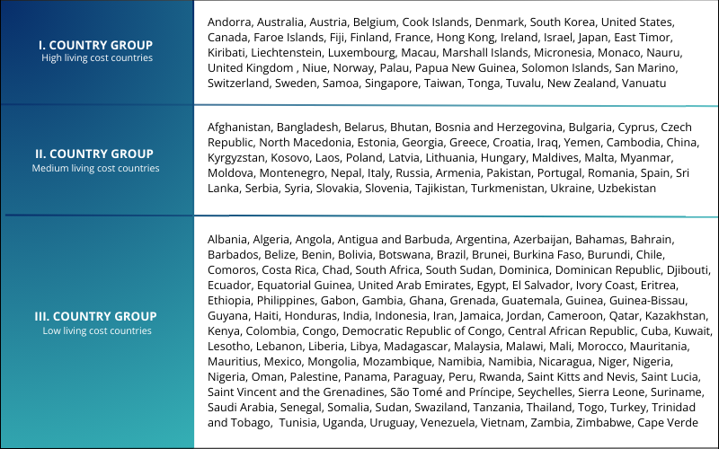
For exact list of the partner institutions please see the list at the end of this call or contact your faculty coordinator.

Who can apply?
General participation conditions:
- the student is pursuing studies aimed at obtaining a diploma (Bachelor, Master, Undivided, PhD) at the institution;
- the student has 1 completed active semester at the time of application;
- in the semester in which the mobility takes place, the student has an active student status at PTE; and do not obtain their degree before the end of the mobility period;
- the student has a high communication level of English and/or language competences corresponding to the native language of the destination country (minimum B2 but recommended C1);
- students with Stipendium Hungaricum scholarship cannot apply for Pannónia grant
- the student is allowed to participate in a study mobility period for a maximum of 12 months per academic cycle, regardless of the number or type of mobility activities
- The student undertakes to complete a minimum of 6 credits from the courses offered by the host partner institution within the framework of the Scholarship Program and to have all completed courses abroad fully accepted.
- meet the application requirements announced by the faculty
Documents to be submitted by the applicants:
- Motivation Letter (approximately 1500 characters)
- Professional CV
- Language certificate(s)
- Transcript of records (2 previous semesters)
- Certificate of professional or public activities (optional)
Grants for the academic year 2026/2027:
The amount of the grant depends on the length of the study period (number of days) and on the host country.
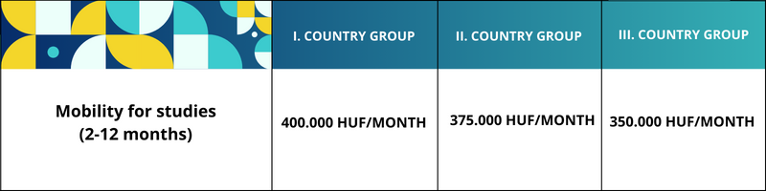
The final scholarships are calculated on a daily basis based on the submitted support agreement.
The amount of the scholarship does not necessarily cover all costs incurred during the stay abroad, these must be covered from other sources.
Under the general mobility program, students participating in partial mobility training are eligible for travel support if the destination of their mobility is more than 2,000 km away(based on RVÉ Decision 2025.11.13) .
The chart below shows the amount of travel support that may be granted based on an institutional decision.
Distance |  | Travel allowance available
Minimum limit | Maximum limit | Travel allowance available
2 000 km | 2 999 km | 86 900 Ft
3 000 km | 3 999 km | 139 200 Ft
4 000 km | 7 999 km | 308 880 Ft
8 000 km |  | 485 800 Ft

Travel distance is calculated exclusively via Erasmus+ Distance Calculator:
https://erasmus-plus.ec.europa.eu/resources-and-tools/distance-calculator
Deadline and method of submitting the application:
Application deadline: 3 o’clock p.m., March 12, 2026 in Neptun.
The Application form in Neptun is available at ”Requests”tab.
Further information about the application will be provided by the faculty coordinator: beata.seres@pte.hu
Please note that incomplete applications, applications that do not meet the requirements, or applications arriving after the deadline will not be accepted. Therefore, please only submit your application in Neptun if you have all the necessary documents at your disposal!
During the preparation of the application, check the course offerings on the websites of the partner universities, the equivalence table appearing on the faculty website; find out in which language and at which training level (bachelor or master's degree) courses are advertised.
The faculty coordinator provides more information about the application and the training courses at partner institutions.

Evaluation of submitted applications:
The submitted applications will be evaluated by the professional committee set up by the faculty, the Faculty External Affairs Committee.
EVALUATION CRITERIA FOR APPLICATIONS
The International Relations Committee evaluates and scores the applications based on the criteria listed in the table below.
Criterion | Maximum Score
1. Academic performance in the major subject / academic portfolio | 30
2. Result of the oral interview | 20
3. Presentation of professional and artistic activities and ambitions in the application | 20
4. Foreign language communication skills / language certificates | 20
5. Public activity, openness to networking, social skills | 10
Total | 100

1. Academic Performance in the Major Subject / Academic Portfolio
Only completed semesters prior to the submission of the application are taken into account, during which the applicant completed at least 15 credits and received a grade of at least 3 (satisfactory) in the major subject.
The score is calculated based on the simple arithmetic mean of the applicant’s grade averages.
Grade Point Average | Score
3.000–3.999 | 17 points
4.000–4.099 | 20 points
4.100–4.199 | 21 points
4.200–4.299 | 22 points
4.300–4.399 | 23 points
4.400–4.499 | 24 points
4.500–4.599 | 25 points
4.600–4.699 | 26 points
4.700–4.799 | 27 points
4.800–4.899 | 28 points
4.900–4.999 | 29 points
5.000 | 30 points

2. Result of the Oral Interview
A maximum of 20 points may be awarded based on the applicant’s performance during the oral interview.

3. Presentation of Professional and Artistic Activities and Ambitions in the Application
- Participation in the National Scientific Students’ Conference (OTDK): 4 points
- Placement among the top ten at the national final of the Scientific Students’ Conference, top three placement at the faculty round, or receiving a special prize: 4 points
- Participation in an academic competition: 2 points
Award-winning participation: 4 points
- Professional publication published in a professional or artistic journal: 6 points
- Membership or activity in a scientific students’ association or honors college: 3 points
- Verified participation in other professional events or conferences, giving a presentation, or submitting a written report or summary: 2 points per activity, maximum 4 points
- Hungarian Republic Scholarship: 5 points

4. Foreign Language Communication Skills / Language Certificates
- State-recognized intermediate-level “C-type” language certificate: 5 points
- State-recognized advanced-level “A-type” or “B-type” language certificate: 7 points
- State-recognized advanced-level “C-type” language certificate: 10 points
If the applicant holds a language certificate in the language of instruction of the host institution: +5 points
Additional language certificates:
- Additional intermediate-level “A-type” or “B-type” certificate: 1 point
- Additional intermediate-level “C-type” certificate: 3 points
- Additional advanced-level “A-type” or “B-type” certificate: 3 points
- Additional advanced-level “C-type” certificate: 5 points
If the applicant does not possess a language certificate, a language interview will determine the score.

5. Public Activity, Openness to Networking, Social Skills
- Executive board membership in the Student Union: 6 points
- Active participation in the work of the Student Union: 4 points
- Committee membership: 4 points
- Active tutor/mentor activity: 4 points
- Membership in an international organization: 8 points
- Other public or community activities – additional points may be awarded; please specify

List of Partner Institutions
1st Semester of the 2026/2027 Academic Year

Note: Information on the foreign-language course offerings of the universities is available on the institutions’ official websites. In certain countries, a B1/B2-level proficiency in the host country’s language is recommended, and in some institutions it is a requirement. Applicants are therefore advised to obtain relevant information in advance regarding language requirements.

Country | Name of University | Field | accepted students per year
Czech Republic | Brno University of Technology | visual | 1
Czech Republic | Jan Evangelista Purkyne University in Usti nad Labem | visual | 2
Germany | Staatliche Akademie der Bildenden Künste Karlsruhe | visual | 1
Spain | University of Granada | visual | 2
Finland | University of Lapland | visual | 2
Finland | Oulu University of Applied Sciences | visual
France | Ecole Supérieure des Beaux-Arts Tours Angers Le Mans | visual | 2
France | Ecole Supérieure d’Art d’Aix-en-Provence | visual | 1
Italy | Accademia Di belle Arti Di Venezia | visual | 2
Italy | Accademia Di Belle Arti Di Napoli | visual | 3
Italy | Academia Di Belle Arti Di Roma | visual | 2
Latvia | Latvian Christian Academy, Jurmala | visual | 2
Poland | The E. Geppert Academyy of Arts and Design in Wroclaw | visual | 2
Romania | Universitatea de Arta si Design din Cluj-Napoca | visual | 2
Slovakia | Technical University of Kosice | visual | 2
Slovakia | Academy of Arts in Banska Bystrica | visual/music | 2
Croatia | Josip Juraj Strossmayer University of Osijek | visual/music | 3/2
United Kingdom | University of Hertfordshire | visual/music | 3
Italy | Conservatorio Statale di Musica “Domenico Cimarosa” Avellino | music | 1
Italy | Conservatorio di Musica "L. Cherubini" di Firenze | music | 2
Italy | Conservatorio di Musica “A. Corelli” Messina | music | 2
Portugal | Instituto Politécnico do Porto | music | 4
Poland | Akademia Muzyczna W Krakowie | music | 3
Poland | Akademia Muzyczna im. I.J. Paderewskiego w Poznaniu | music | 1
Romania | Universitatea Babes-Bolyai Cluj-Napoca | music | 2
Romania | Academia de Muzica "Gheorghe Dima" | music | 2
Romania | University of Theatre of Tirgu Mures | music | 1
Slovakia | Academy of Performing Arts in Bratislava | music | 2
Spain | Conservatorio Superior de Música "Eduardo Martínez Torner" del Principado de Austrias, Oviedo | music | 3
Spain | Conservatorio Superior de Música de Canarias, Las Palmas | music | 2

Outside of Europe:

https://mobilitas.pte.hu/osztondijak/hallgatoi/tengeren_tuli

Prof. Péter Lengyel
dean
Faculty of Music and Visual Arts

